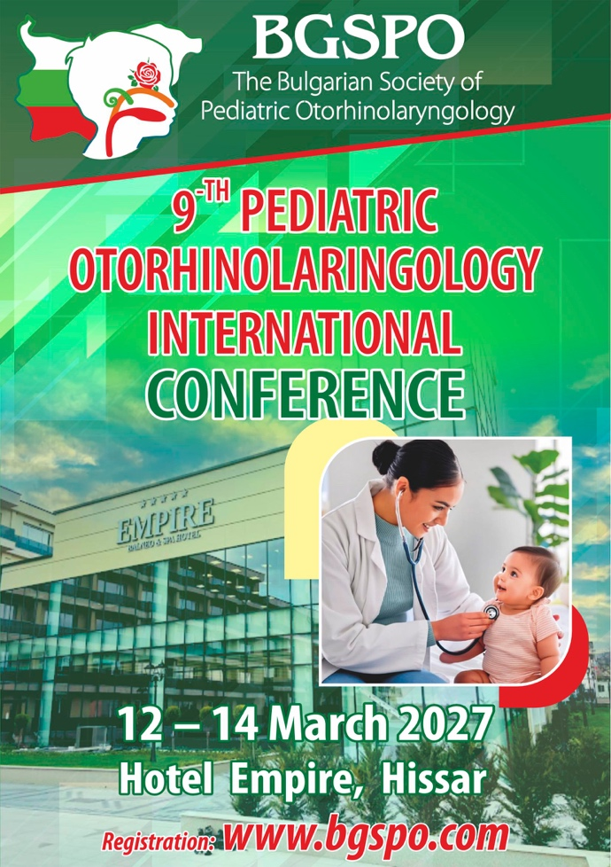

Please save the completed form and send it as an attachment to:
office.bgspo@gmail.com
ABSTRACT FORM
INFORMATION ABOUT THE AUTHOR
Submission deadline:
18 January 2027
Name | Middle name | Family name
Institution:

Address:
Mobile phone:
e-mail:

SUMMARY
Method of presentation: | report | poster
Scientific subject:
Title:
Author team:

INSTRUCTIONS FOR AUTHORS:
- The abstract should not exceed more than 300 words;
- The summaries must be written in English accordingly;
- Abstracts should be structured in 4 parts:
- Aim of the study,
- Material and methods,
- results,
- Conclusion
- Use a title that indicates the content of the abstract.
- The title must be in CAPITAL LETTERS
- Avoid using abbreviations in the title.
- For words that are abbreviated, use the full name the first time they are used, followed by
from the standard abbreviation in parentheses
- Please write the name or names of the authors under the title, underlining the name of the author who
will present the message or poster. Below them, please write the name of the institution

ABSTRACT

